**Topics: Descriptive Statistics and Probability**

1. Look at the data given below. Plot the data, find the outliers and find out $μ, σ, σ^{2}$

|  |  |
| --- | --- |
| **Name of company** | **Measure X** |
| Allied Signal | 24.23% |
| Bankers Trust | 25.53% |
| General Mills | 25.41% |
| ITT Industries | 24.14% |
| J.P.Morgan & Co. | 29.62% |
| Lehman Brothers | 28.25% |
| Marriott | 25.81% |
| MCI | 24.39% |
| Merrill Lynch | 40.26% |
| Microsoft | 32.95% |
| Morgan Stanley | 91.36% |
| Sun Microsystems | 25.99% |
| Travelers | 39.42% |
| US Airways | 26.71% |
| Warner-Lambert | 35.00% |

Ans:

Mean=0.3327

Standard deviation=0.1694

Variance=0.0287

Outliers=0.9

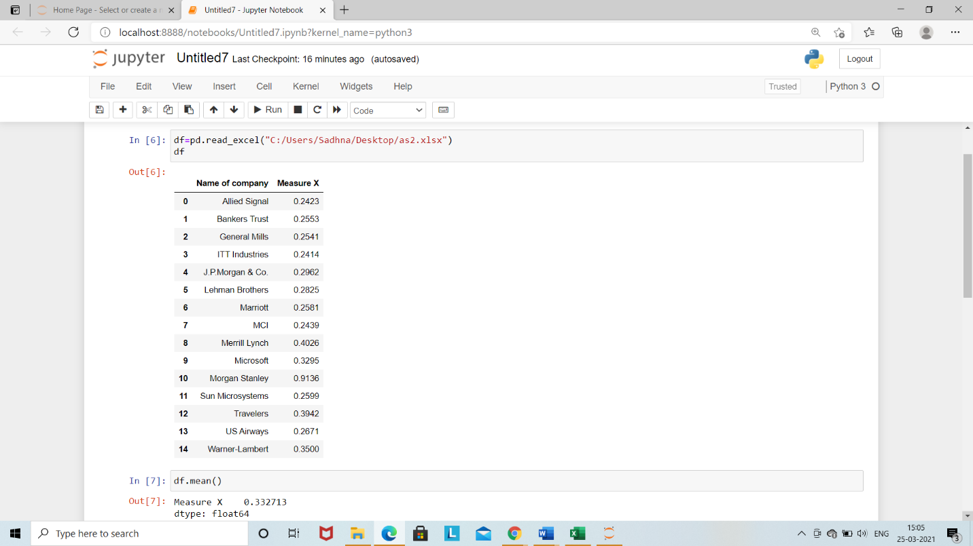

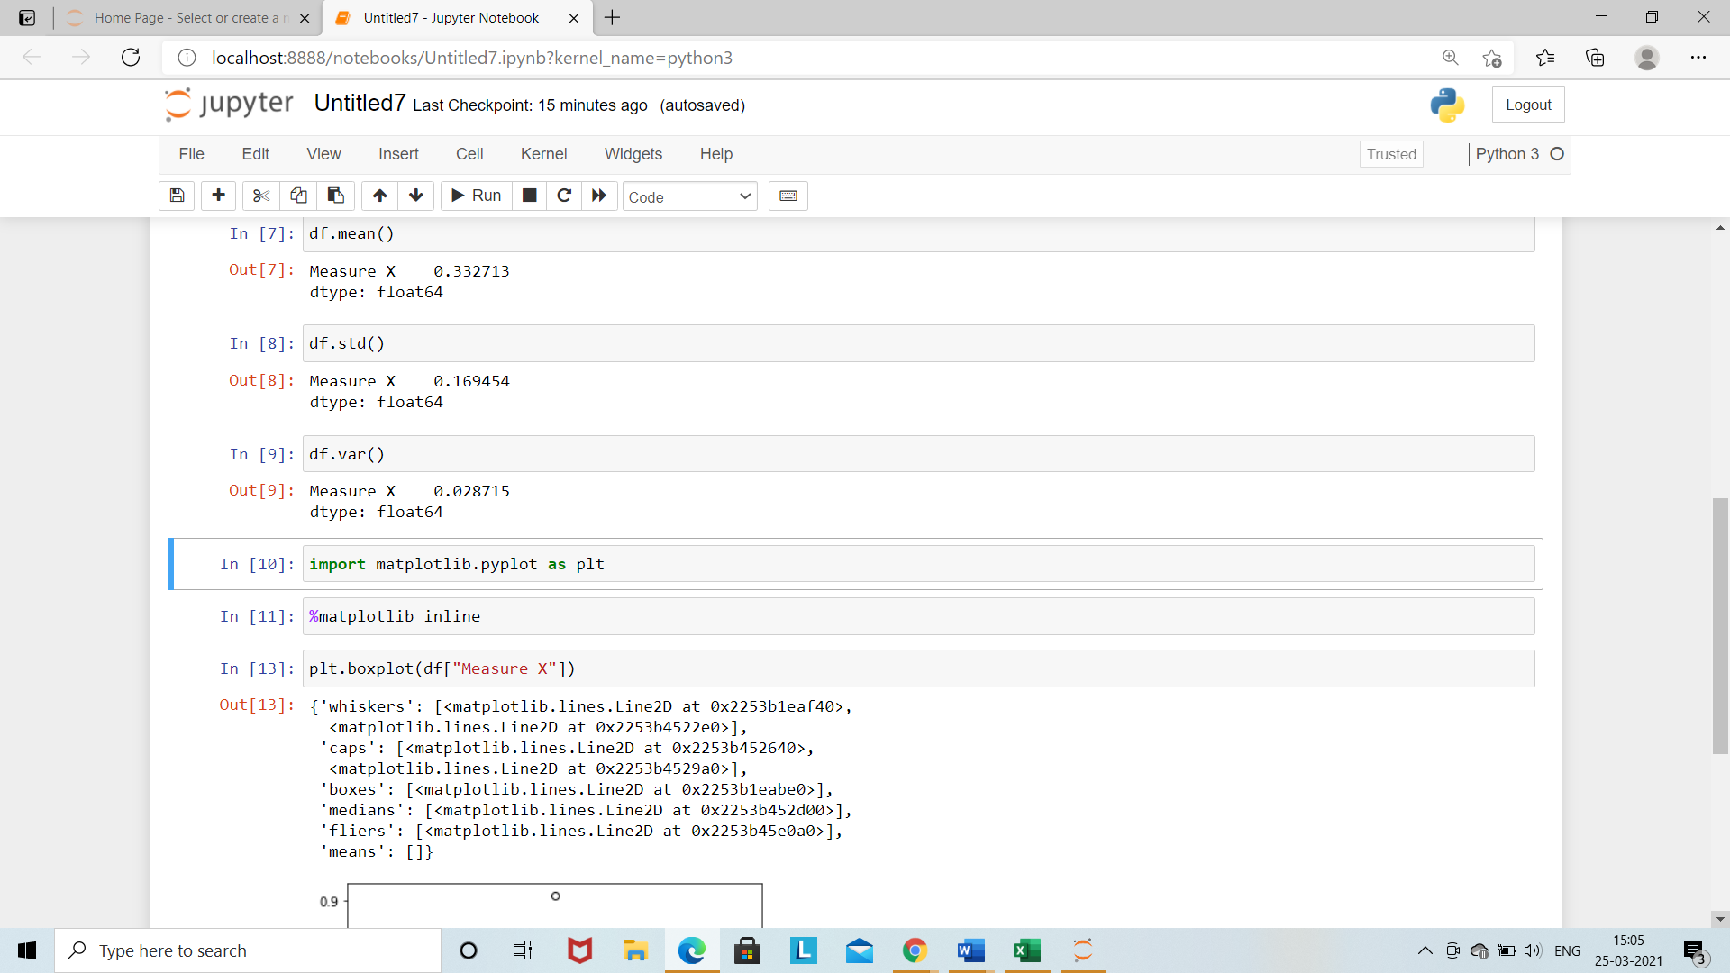

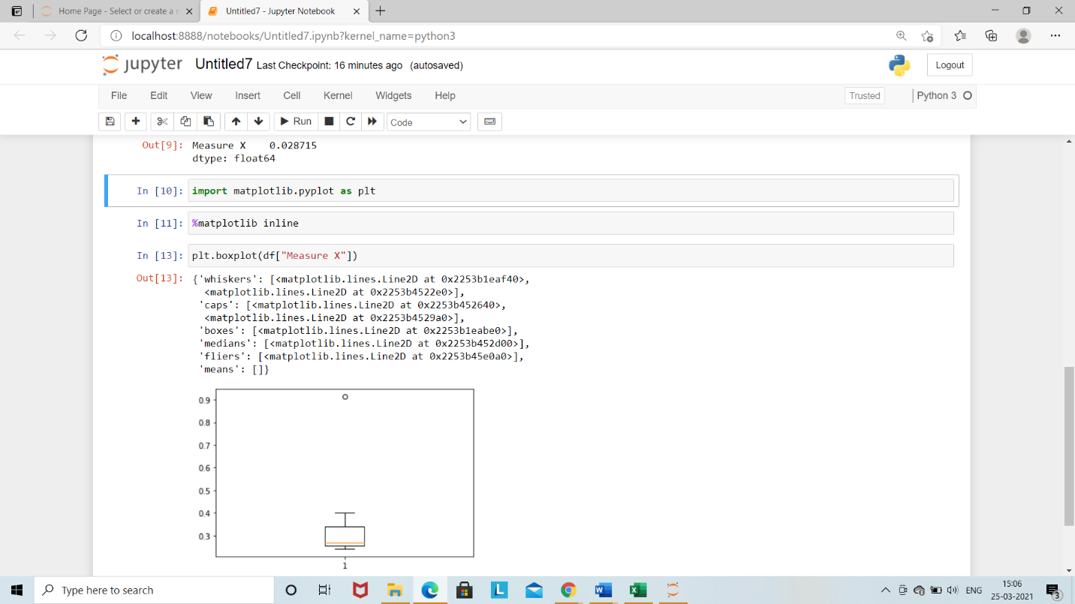



Answer the following three questions based on the box-plot above.

1. What is inter-quartile range of this dataset? (please approximate the numbers) In one line, explain what this value implies.

ANS: IQR=q3-q1

= 12-5

=7

The IQR describes the middle 50% of value when ordered from lowest to highest.

1. What can we say about the skewness of this dataset?

ANS: Th nature of the boxplot is positive skewness.

1. If it was found that the data point with the value 25 is actually 2.5, how would the new box-plot be affected?

ANS: yes, there is effect on box-plot

There will be no outlier present in the plot. The points present in whisker region.



Answer the following three questions based on the histogram above.

1. Where would the mode of this dataset lie?

ANS: The mode of the dataset lies approximately between 4.4 to 7.9

1. Comment on the skewness of the dataset.

ANS: The nature is positive skewness

1. Suppose that the above histogram and the box-plot in question 2 are plotted for the same dataset. Explain how these graphs complement each other in providing information about any dataset.

ANS: Histograms gives a good sense of the distributed variable. Box plot attempt to do same thing however, don’t give as good sense of picture of the distribution of this variable. but one advantage of box plot is it shows the outliers.

1. AT&T was running commercials in 1990 aimed at luring back customers who had switched to one of the other long-distance phone service providers. One such commercial shows a businessman trying to reach Phoenix and mistakenly getting Fiji, where a half-naked native on a beach responds incomprehensibly in Polynesian. When asked about this advertisement, AT&T admitted that the portrayed incident did not actually take place but added that this was an enactment of something that “could happen.” Suppose that one in 200 long-distance telephone calls is misdirected. What is the probability that at least one in five attempted telephone calls reaches the wrong number? (Assume independence of attempts.)

Ans: The probability of misdirecting=1/200

The probability of not misdirecting=1-1/200

=199/200

No. of calls=5

P(X)= ^nCxP^xq^n-x

n=5

P=1/200

Q=199/200

At least one in five attempted telephone calls reaches the wrong number= 1- no call reaches

the wrong

= 1- P (0)

= 1- ^5C*0*(1/200) ^09199/200) ^5-0

=0.02475

1. Returns on a certain business venture, to the nearest $1,000, are known to follow the following probability distribution

|  |  |
| --- | --- |
| x | P(x) |
| -2,000 | 0.1 |
| -1,000 | 0.1 |
| 0 | 0.2 |
| 1000 | 0.2 |
| 2000 | 0.3 |
| 3000 | 0.1 |

1. What is the most likely monetary outcome of the business venture?

ANS: for negative=0.1+0.1=0.2

For positive it will be=0.2+0.3+0.1=0.6

1. Is the venture likely to be successful? Explain

Ans: yes, because it gives more positive outcomes

1. What is the long-term average earning of business ventures of this kind? Explain

Ans: the long-term average earning is 0.6-0.2=0.4

1. What is the good measure of the risk involved in a venture of this kind? Compute this measure

Ans: the positive outcomes will be 0.8

0.8-0.2=0.6